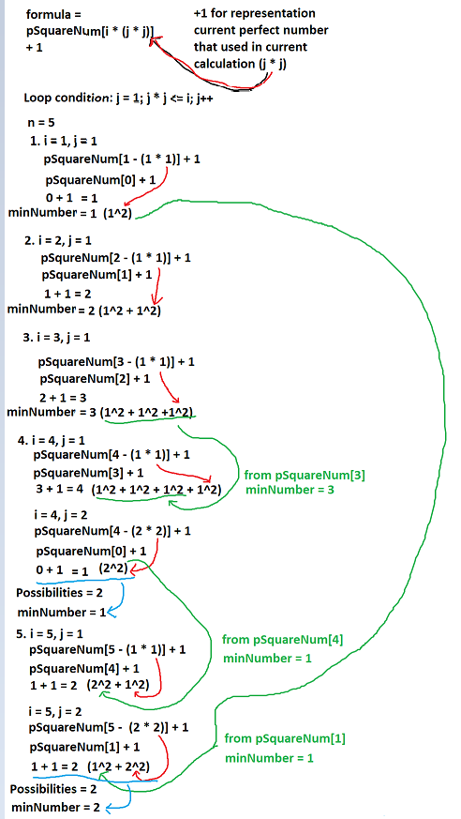

Let’s break down:

1. For **i** = 1, there's only one possibility: 1 itself. So, **pSquareNum[1]** = 1.
2. For **i** = 2, the possibilities are **12 + 12** = 2. The minimum number is 2 (1, 1), so **pSquareNum[2]** = 2.
3. For **i** = 3, the possibilities are **12 + 12 + 12**= 3. The minimum number is 3 (1, 1, 1), so **pSquareNum[3]** = 3.
4. For **i** = 4, the possibilities are **12 + 12 + 12 + 12**= 4, or **22**= 4. The minimum number is 1 (2= 4 itself), so pSquareNum**[4]** = 1.
5. For **i** = 5, the possibilities are **22 + 12**= 5, or **12 + 22**= 5. The minimum number is 2 (1, 2), so **pSquareNum[5]** = 2.

And so on...

What actually happened here ?

n = 5

* 1st loop for represents each number from 1 to n, which mean 1 to 5 and store each value that will be obtained in the second loop
* 2nd loop is used to find the minimum number of perfect square numbers needed to reach the current i. And reuse the previously computed minimum number for the remaining value
* + 1 for represents the current perfect square used in the calculation.

In this case, we will get 2 possibilities because of loop condition

1. i = 5, j = 1

pSquareNum[5 – (1 * 1)] + 1

pSquareNum[4] + 1

at this point we will directly reuse the previously computed minimum number at pSquareNum[4], which mean 1

1 + 1 = 2

1 (without current square) + 1 (current square)

Minimum number at possibility 1 = 2

1. i = 5, j = 2

pSquareNum[5 – (2 * 2)] + 1

pSquareNum[1] + 1

at this point we will directly reuse the previously computed minimum number at pSquareNum[1], which mean 1

1 + 1 = 2

1 (without current square) + 1 (current square)

Minimum number at possibility 2 = 2

Because both of possibilities minimum number for this case is 2.

And the result will be 2

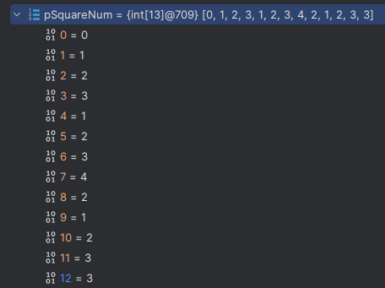

public static int numSquares(int n) {  
 int[] pSquareNum = new int[n + 1];  
   
 for (int i = 1; i <= n; i++) {  
 pSquareNum[i] = i;  
   
 for (int j = 1; j * j <= i; j++) {  
 int remainingValue = i - (j * j);  
 pSquareNum[i] = Math.*min*(pSquareNum[i], pSquareNum[remainingValue] + 1);  
 }  
 }  
 return pSquareNum[n];  
}

The explanation for the code:

1. An array **pSquareNum** is created, for store the minimum number of perfect square numbers
2. The 1st loop iterates from 1 to **n**, it’s for representing each number from 1 to **n**
3. The 2nd loop iterates over possible perfect square numbers (**j** * **j**) where **j** is less than or equal to the current index **i**
4. For each **j**, it calculates the minimum number of perfect square numbers needed to reach the current index **i** by subtracting (**j** * **j**) from **i**
   1. **i** - (**j** * **j**): This expression represents the remaining value after subtracting a perfect square (**j** * **j**) from the current index **i**. In other words, it calculates the difference between the current number **i** and a perfect square (**j** * **j**)
   2. **pSquareNum**[**i** - (**j** * **j**)]: This part retrieves the minimum number of perfect square numbers needed to reach the remaining value calculated in step **a**. The idea is to reuse the previously computed minimum number for the remaining value
   3. + 1: Since we are using a perfect square (**j** * **j**), we add 1 to the minimum number obtained in step **b**. This addition for represent the current perfect square used in the calculation.
5. After both loops, the function returns the value stored in **pSquareNum[n].** The final line **pSquareNum[i] = Math.min(pSquareNum[i], minNumber)**; ensures that the array **pSquareNum** at index **i** contains the minimum number of perfect squares needed to sum up to **i.**